World Wide Public Holidays

Author: Balan Ana

Iasi, 2020

Content

1. Let’s talk about App’s Primary features,
2. What does the used API return?

2.1. Holiday Object

2.2. Dates

2.3. Name

2.4. Types of Holiday

1. App’s Body
2. Error 404
3. API address
4. Let’s talk about App’s Primary features

This App provides dates of holidays for various countries, states and regions, while considering the applicable time zone.

The features are:

* calculation of public, bank and observance holidays for different countries following ISO 3166-2
* consideration of time zones for holiday checks
* consideration of start and end time dependent on time zone
* substitute days
* multi-language support for all holiday names

1. What does the used API return?
   1. Holiday Object

getHolidays() call return either a list or a single holiday object which consists of:

|  |  |
| --- | --- |
| date | string(date)  Date |
| localName | string *nullable: true*  Local name |
| name | string *nullable: true*  English name |
| countryCode | string *nullable: true*  ISO 3166-1 alpha-2 |
| Is global | boolean  Is this public holiday in every county (federal state) |
| Launch Year | integer($int32) *nullable: true*  The launch year of the public holiday |
| type | PublicHolidayTypestringEnum: [ Public, Bank, School, Authorities, Optional, Observance ] |

Response model:

[

…

{

"date":"2020-12-08",

"localName":"Mariä Empfängnis",

"name":"Immaculate Conception",

"countryCode":"DE",

"isGlobal ":true,

"launchYear":N/A,

"type":"Public"

},

{

"date":"2020-12-25",

"localName":"Weihnachten",

"name":"Christmas Day",

"countryCode":"DE",

"isGlobal":true,

"launchYear":N/A,

"type":"Public"

},

{

"date":"2020-12-26",

"localName":"Stefanitag",

"name":"St. Stephen's Day",

"countryCode":"DE",

"isGlobal ":true,

"launchYear":N/A,

"type":"Public"

}

…

]

* 1. Date

The ***date*** String represents the start date of the holiday in ISO format without time zone. This string it intended for information only.

* 1. Name (English name)

The ***name*** names of the holiday in the local language of the selected country, state, region. The applied language(s) is requested using getLanguages().

The language can be changed using the setLanguages() method. In case that not translation is available a fall-back to the next given language will be made. E.g. local language is "de", setLanguages('dk') was called. For all holidays where no denmark translation is available the German version will be used instead.

All holiday names support an English translation.

* 1. Types of Holiday

The following types with their meaning are supported:

| **type** | **meaning** |
| --- | --- |
| public | public holiday |
| bank | bank holiday, banks and offices are closed |
| school | school holiday, schools are closed |
| optional | majority of people take a day off |
| observance | optional festivity, no paid day off |

1. App’s body

The main parts of the App are:

- Header

- Menu bar

- Calendar

- Sorting form

- Table with the holidays

- Footer

Let’s go through and talk about them.

* 1. Header

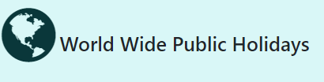The Header includes the App’s name and a logo:

* 1. Menu Bar

The menu bar consists from two parts:

1. Sections: Home, About and Contact us,
2. Social Following

*Choosing:

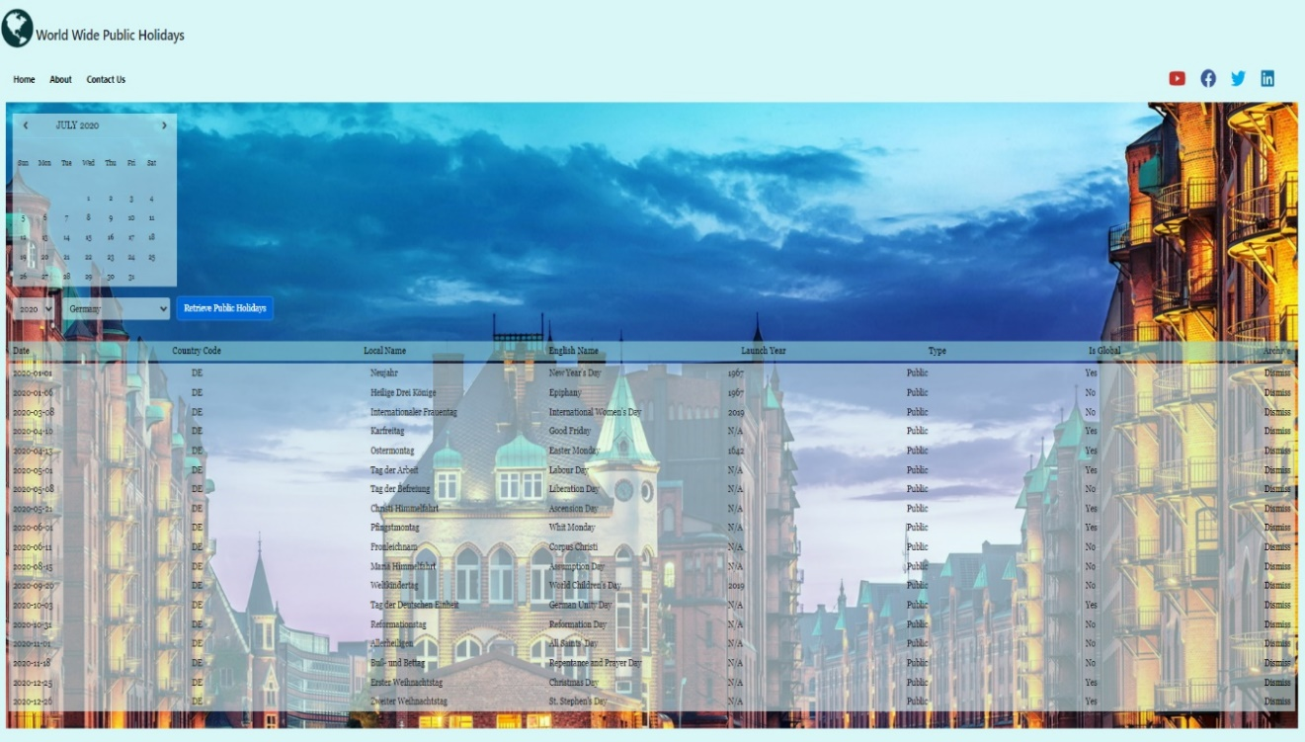**Home** - you will be redirected to the main page:

*the default country is - Germany



and the default year – 2020



The App will display a background images depending on the country (countryCode) you choose:





**About** - here you can read something interesting about us and our project,

**Contact us** – if there are some issues, please do not hesitate to contact us. It works this way:

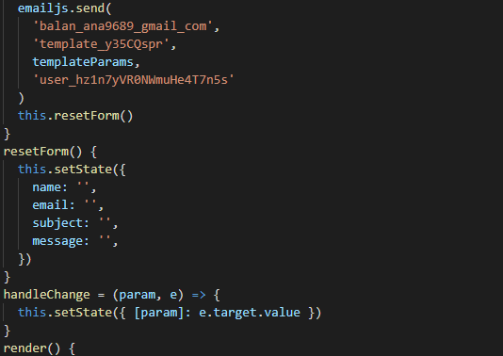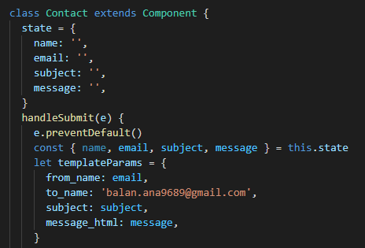

*For receiving emails, I used the platform “<https://www.emailjs.com/>”

* 1. Calendar

The calendar was built from A to Z. The cells are generated dynamically and populated.

There was created a table with 7 columns, the table headings ‘Sunday’ to ‘Saturday’, ‘previous’ and ‘next’ dropdowns to navigate months, and year.

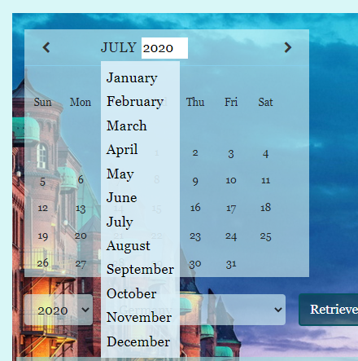

The scope of this calendar is to help the user to check immediately on which day of the week the holiday falls. In this way the user avoids to search this information on other sources.

The holiday table isn’t integrated in the calendar (not yet).

* 1. Sorting form

The sorting form consists from three elements:

-Two dropdown lists, one for Years, one for Countries,



-A button for retrieving the table content.



* 1. Table with the holidays

By selecting the desired Year and Country, the Button “Retrieve Public Holidays” will return a table with the requested information:

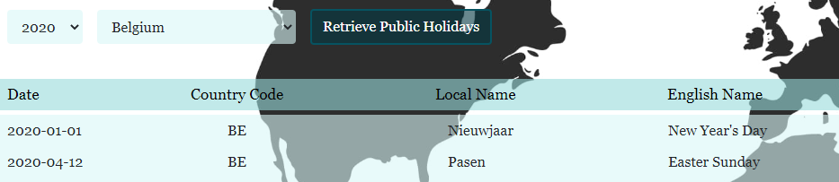

*each column can be alphabetically sorted.

In the case the user wants to reduce the rows of the holidays on his page, the user can easily do that using the “dismiss” button, it allows to “hide” the rows:

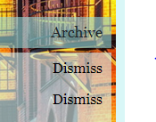

* 1. Footer

The Footer has a simple design, it contains information regarding the current year, and copyright.

Behind the scene:



What the user sees:



1. Error 404

In case the user decides to type the path to go to a section from the menu bar and it is wrong, the App will return a personalized 404 Error.

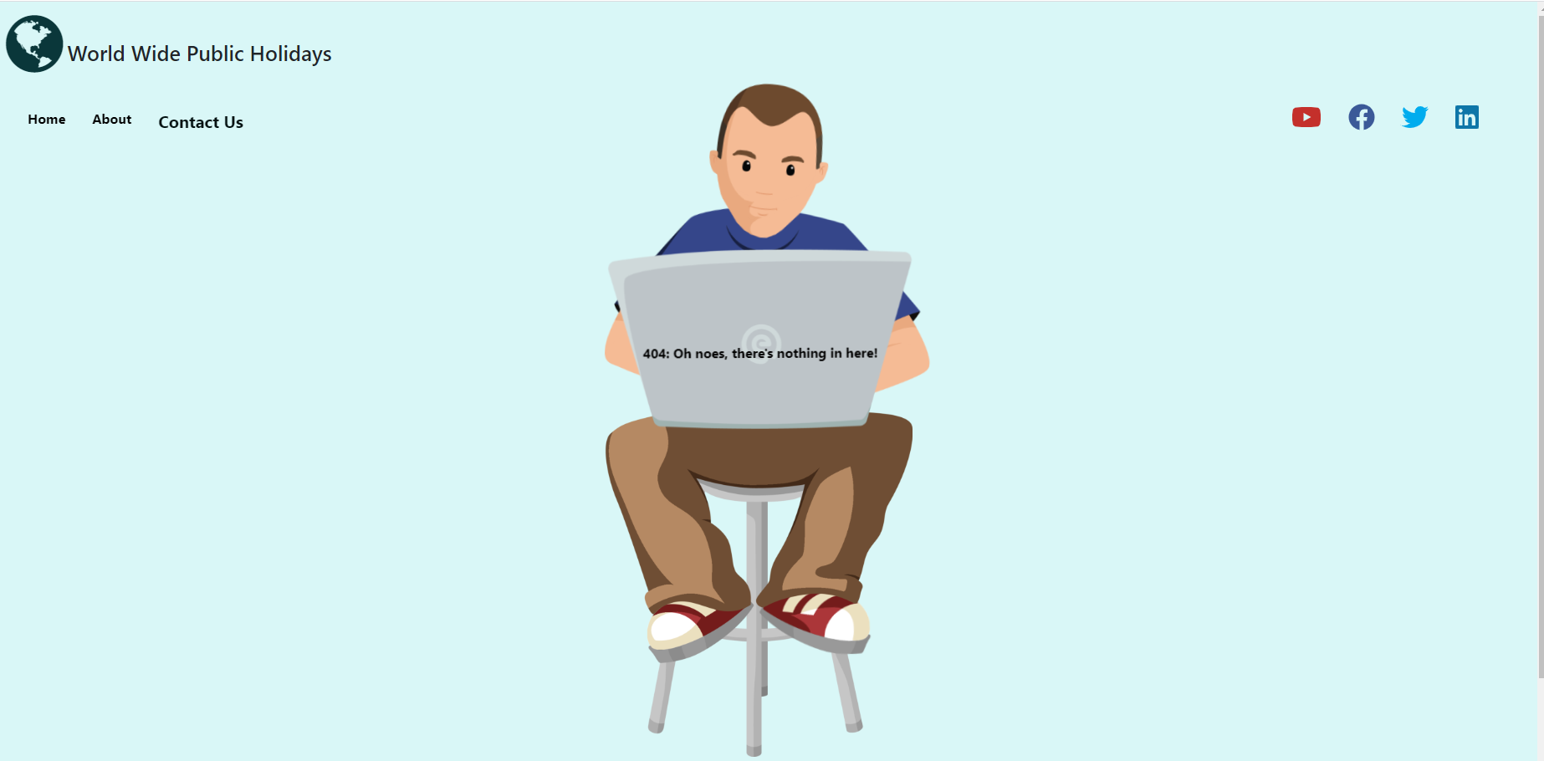

1. API address

The address of the API I used for my App, can be visited clicking the link below:

<https://date.nager.at/Api>

**Thank you for reading this!**